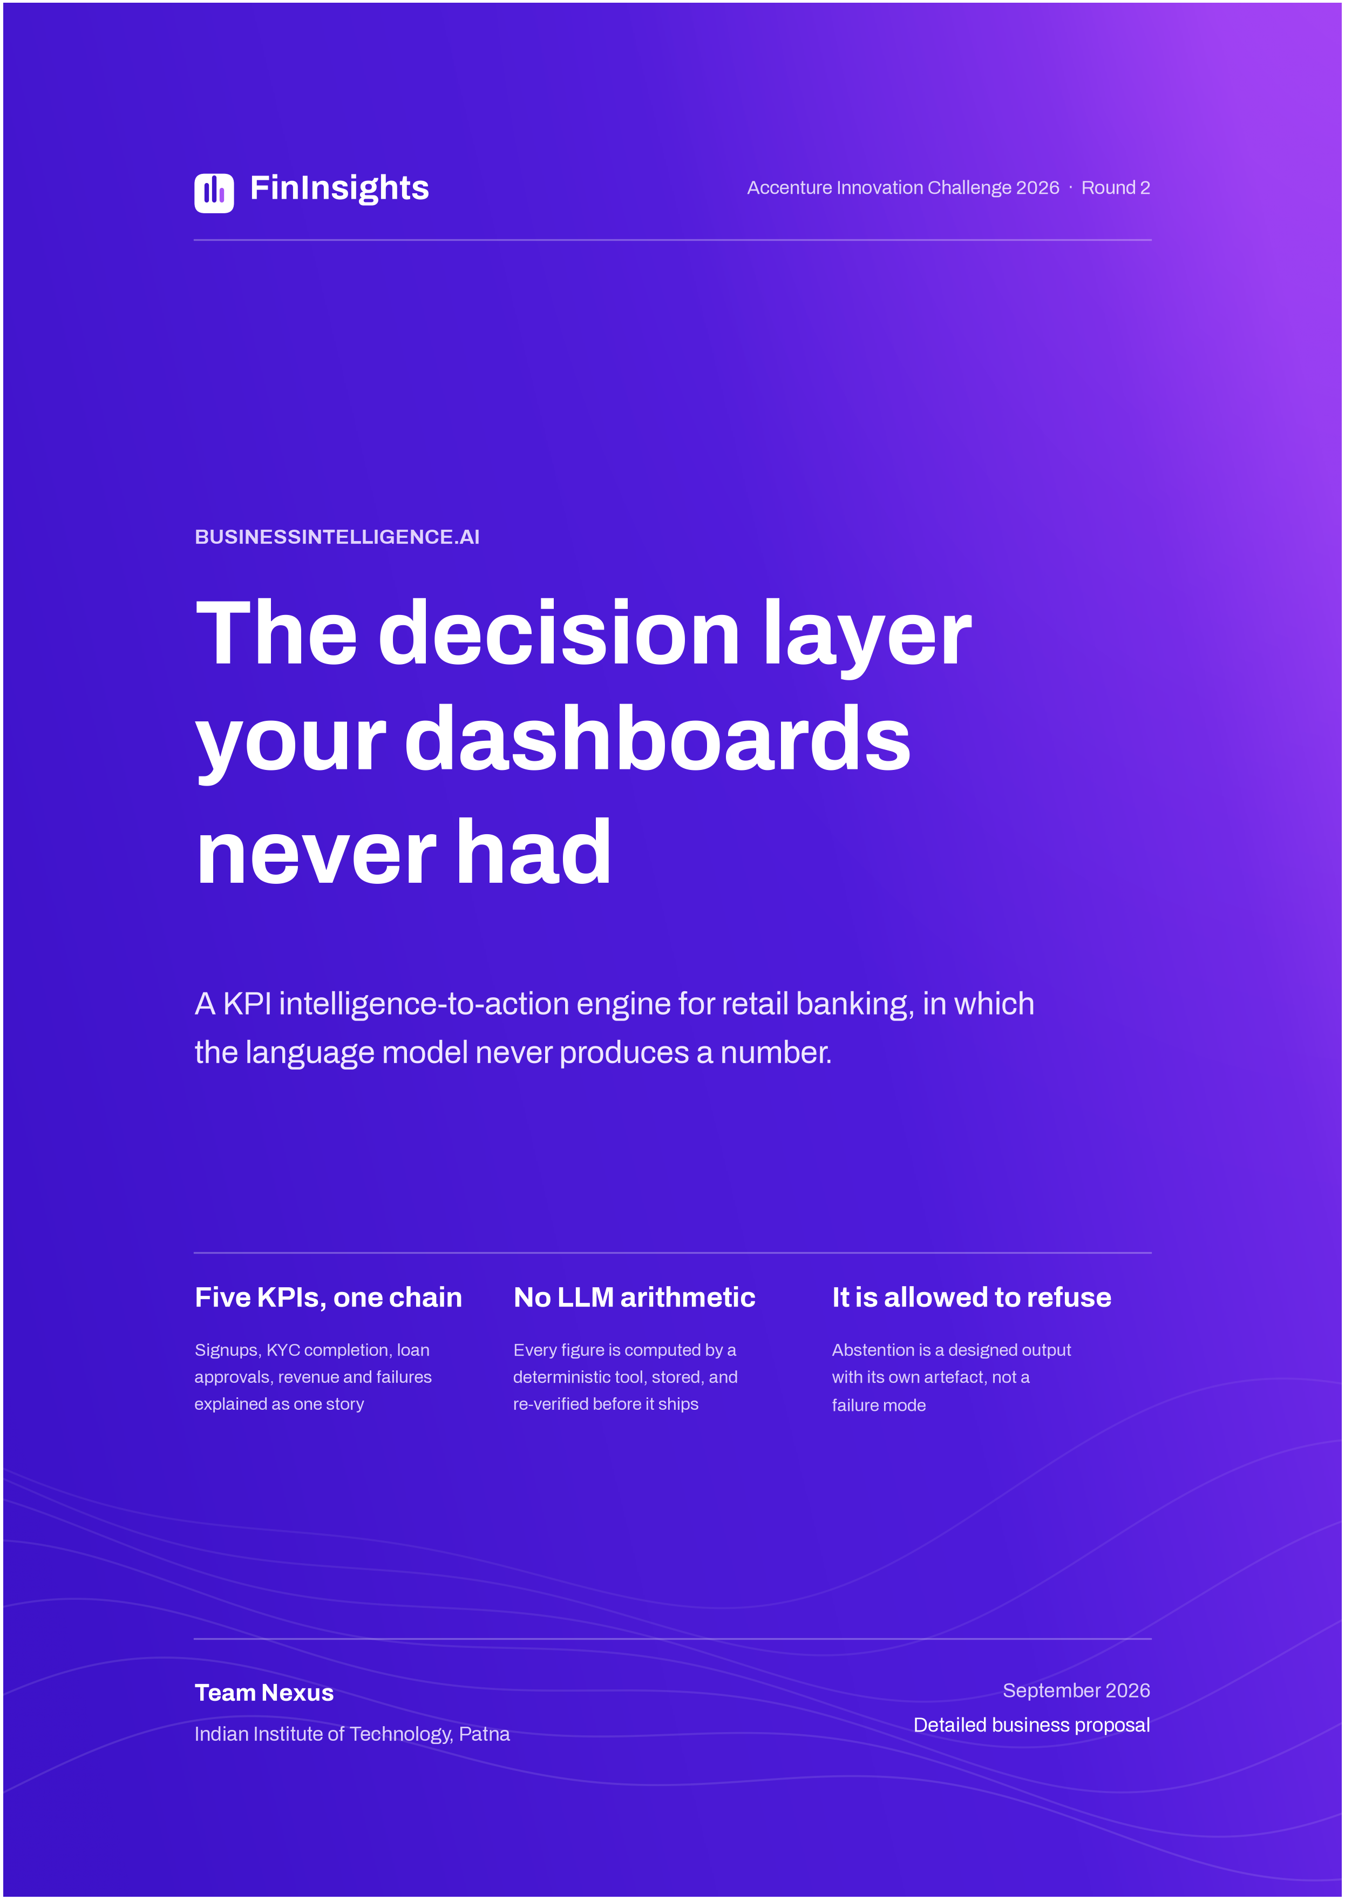

Document control

Field | Detail
Prepared for | Finance, operations, risk and data leadership at a mid-size retail bank
Submitted by | Team Nexus, Indian Institute of Technology Patna
Problem statement | BusinessIntelligence.ai, Accenture Innovation Challenge 2026, Round 2
Reference build | FinInsights running end to end on NexaBank, our own banking application and event source
Date | September 2026
How to read the numbers | Every figure carries one of four labels. Sourced means an external reference, linked. Modelled means our assumption, stated so you can replace it. Illustrative means a worked example of a method, not output from a run. From the build means it describes what the code does. Nothing here is measured at a client, and nothing is presented as though it were.

Contents
 | Section | What it settles
 | Executive brief | The decision, the numbers, and the ask
1 | The problem | The cost is the day after the alert
2 | Solution design | Seven stages compute. One writes.
3 | The KPI chain and its contracts | Five metrics, two cadences, one causal spine
4 | Readers and entitlement | Three people, one set of verified claims
5 | Prototype evidence | The four scenarios the brief asks for
6 | Evidence and run cost | What travels with every insight
7 | The feedback loop | Learning without retraining anything
8 | Business case | A floor we will defend line by line
9 | Roadmap | Three phases, each gated on evidence
10 | Risk register | The three that would kill it are not technical
11 | Success criteria | What to test during a pilot
12 | Commercial model | Where to land, and what it is worth
13 | Recommendation | The decision requested
A | Method register | The published work behind each tool
B | References | Every external claim, with a link
C | Glossary | Terms as this product uses them

Executive brief
Your dashboards are fine.
The day after the alert is not.
Every bank in your peer group owns a warehouse, a BI tool and an alerting surface. None of them answers the question a leader actually asks, which is not what changed but why, how sure are you, and what should I do about it. Today an analyst answers that by hand, over most of a working day. FinInsights does that day’s work with deterministic tools, and stays quiet when the evidence will not carry an answer.
The engine watches five connected banking metrics across two sources that refresh at different speeds. It checks the data before it says anything about it. It finds the segment carrying a movement, forecasts with an honest interval, estimates a causal effect only where the assumptions survive a test, and proposes one action from a closed list of levers with a named owner. A small language model reads the question and writes the answer. It never produces a number.
The one decision everything else follows from
The model may choose the path. It may not choose the numbers. Every figure a reader sees is computed by a deterministic tool, written to a store alongside the engine that produced it, and checked back against that row before the sentence ships. Switch the model off and not one number changes. The findings still arrive, in a fixed format instead of prose.

Why this is worth doing now
Data teams have already adopted AI, but only on one side of the work. In dbt Labs’ 2026 survey of 363 practitioners, 72% now use AI to help write the code that produces their numbers. Just 24% use it to test, observe or check what comes out. In the same survey, 71% named incorrect or hallucinated output reaching stakeholders as a top concern (dbt Labs, April 2026).
The appetite is there. So is the anxiety. What is missing is a layer that treats the model as a writer rather than a calculator, and that leaves an audit trail a model risk function will actually accept.
What we are claiming, and how sure we are
$335K  Annual value floor we will defend line by line, before the wider range  Modelled, section 8.1 | 3 to 5  Months to payback on a bounded implementation and licence profile  Modelled, section 8.2 | 5  Connected KPIs running end to end on our own banking application today  From the build, section 3 | 0  Numbers in a narrative the verifier could not trace back to a stored row  By design, section 6.2

The floor is the number to argue with. It is the bottom-up sum of four mechanisms, each resting on an assumption you can dispute in section 8. A wider range of $550K to $950K appears once in-time decision value and analyst retention are counted, but we lead with the floor on purpose. A range we cannot bound is a weaker position than a smaller one we can.
What we are asking for
Authorise a governed pilot on the lending and onboarding loop, where KYC completion, loan approval volume and revenue form one connected story. Use it to replace the modelled lines in section 8 with measured ones. The Phase 1 exit test is concrete, and you can run it yourself. The Trust Gate has to quarantine a corrupt batch we seed. The verifier has to pass on every published figure. An analyst has to be able to review a completed investigation inside an hour.

Section 1
The cost is not measurement.
It is the day after the alert.
Four published figures frame the gap. None of them are ours. They describe the same failure from four directions: trust, verification, precision, and what happens to programmes that ignore all three.
71%  Of data professionals worry about incorrect or hallucinated output reaching stakeholders  dbt Labs, 2026 | 24%  Use AI to test and observe their pipelines, against 72% who use it to write code  dbt Labs, 2026 | 46%  Of security alerts prove to be false positives, the closest well-measured analogue  Microsoft and Omdia, 2026 | 42%  Of firms abandoned most of their AI initiatives during 2025, up from 17%  S&P Global, 2025

Read together they describe one workflow rather than four complaints. Teams are generating faster than they are checking. People do not trust what comes out. The alerting surface meant to help is wrong about half the time, so they stop reading it. Programmes built on top of all three tend not to survive their second year.
1.1 Six hours to answer one question, and five and a half of them are clerical
A single metric investigation at a mid-size retail bank takes roughly six analyst hours. How those hours split is the whole argument.
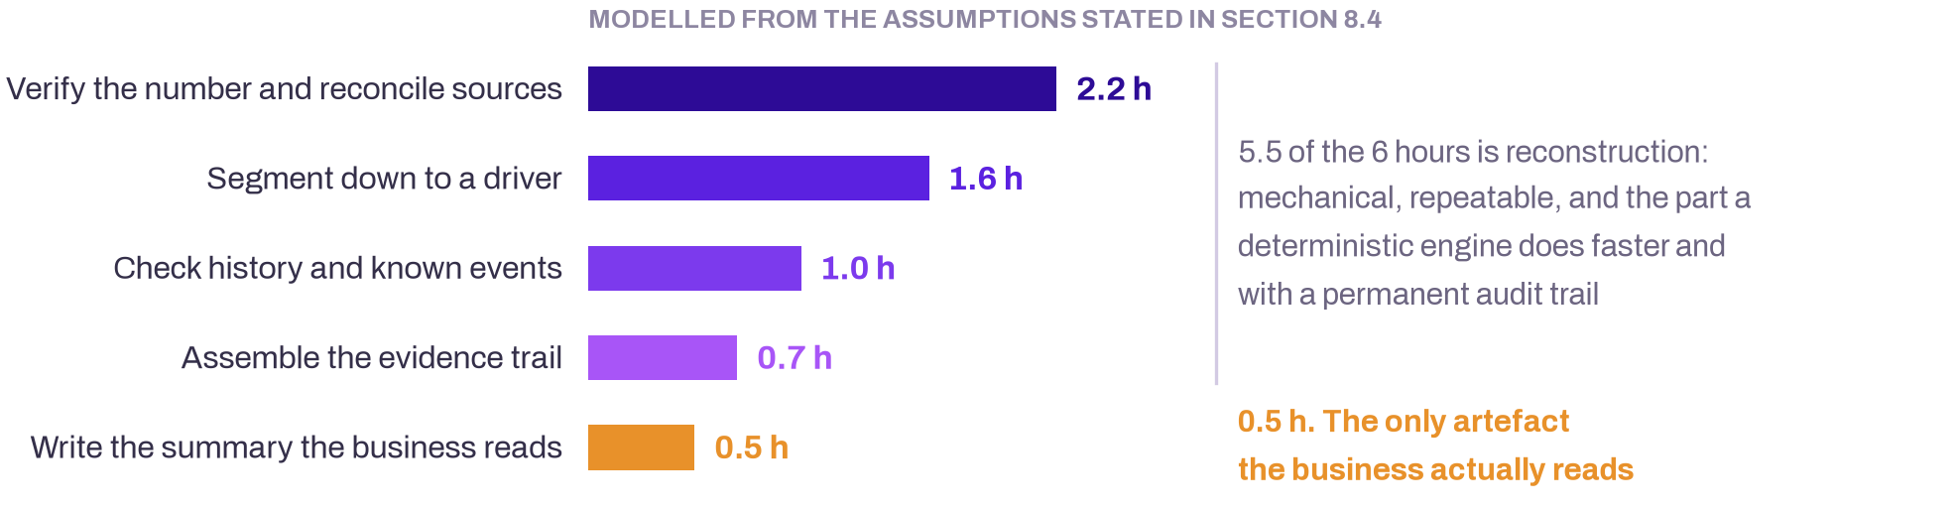
Verification and segmentation are mechanical and repeatable. Judgement, the part only a person can supply, gets what is left over.
The ratio is upside down. The last 8% of the effort produces the only artefact a decision-maker ever reads. The first 92% is reconstruction, and reconstruction is exactly what a deterministic system does faster, more consistently, and with a trail that still holds up six months later. At $55 a loaded analyst hour and about 600 investigations a year, that reconstruction costs roughly $165K.
1.2 Three ways the status quo leaks money
 | Mechanism | Annual cost | What actually happens
1 | The analyst-day | $165K  analyst time | Verification, reconciliation and segmentation eat the investigation. Judgement, the scarce input, gets the remainder.
2 | The confidently wrong answer | $120K to $160K  avoidable decisions | A duplicated batch produces a spike that looks statistically real. Charts render it, alerts fire, a meeting happens. The movement never did. The decision did.
3 | The reporting bottleneck | $25K to $40K  duplicated reporting | Finance, operations and analytics need one truth told three ways, with different figures visible to each. Today that gets built by hand, three times, from one spreadsheet.
Modelled from the volumes and unit costs in section 8.4. The cost of analyst time is externally anchored. The frequencies are ours.
1.3 Why the stack you already own cannot close it
Most institutions in this segment own at least three of the four categories below. In every case the reason the gap survives is structural rather than a missing feature.
Category | What it does well | Why the gap survives
BI dashboards | Render what changed, quickly. | They hold no opinion on whether the change can be trusted, so the burden of proof lands on an analyst every single time. A dashboard cannot refuse to draw a corrupted series.
Alerting | Tell you something moved. | At roughly half precision the organisational response is to stop reading them. Volume without precision is noise with a budget line.
Conversational analytics | Answer in fluent prose. | Fluency is not accuracy. Leading text-to-SQL systems still miss about one BIRD question in five, and real warehouse schemas run past a thousand columns where correct answers run past a hundred lines of SQL.
Data observability | Catch the broken pipeline. | Then stop. No segment, no cause, no action, no reader. It tells engineering a table is stale. It never tells an operations manager which cohort to call.

Source: Microsoft and Omdia, State of the SOC 2026 · BIRD leaderboard · Spider 2.0, ICLR 2025
These four are complements, not competitors. FinInsights consumes what they produce, including freshness signals, pipeline health and the warehouse itself. It occupies the one layer none of them does: a verdict on whether a movement may be spoken about at all, and to whom.

Section 2
Seven stages compute. One writes.
The architecture is a chain. The Trust Gate sits second on purpose, because its job is to be able to stop the chain and emit nothing.
The brief asks teams to show where they use deterministic logic, SQL, business rules, statistics, traditional ML, causal inference, retrieval and language models, and why. For this product that answer fits in one picture, so it is worth drawing before anything else.
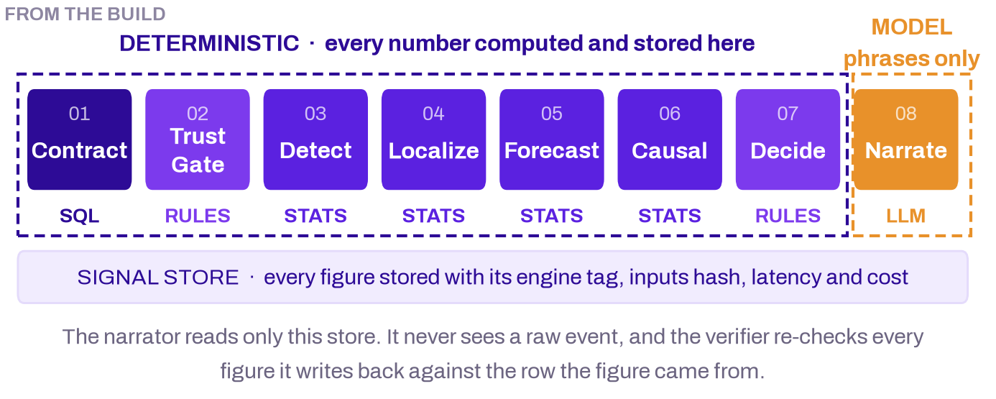
Seven of the eight stages run on CPU with no model anywhere in the path. The eighth turns finished, verified findings into a sentence. This breakdown is read back from stored records rather than asserted, because every figure carries the engine tag of the tool that produced it.
The boundary sits here for a practical reason rather than a cautious one. The two sides fail differently. A deterministic stage that is wrong is wrong the same way every time, so you can find it and fix it. A model that is wrong is wrong differently on every run, in the same confident prose it uses when it is right.
2.1 What each stage decides
 | Stage | Method | The decision it makes
01 | Contract | Declarative YAML, one file per KPI | What the number means, at what grain, from which fundamentals, and who may see it
02 | Trust Gate | Business rules and SQL invariants | Whether this figure may be used at all, and if not, what gets emitted instead
03 | Detect | Median and MAD residuals, Benjamini-Hochberg FDR control | Whether the move is unlikely, material and persistent enough to interrupt a person
04 | Localize | PSqueeze over the segment cube, LMDI-I decomposition | Which cells carry the movement, how much each explains, and how much is left over
05 | Forecast | Method registry scored on rolling-origin MASE | What to expect next, as an interval, and how wide that interval honestly has to be
06 | Causal | Difference-in-differences with a placebo test | How much of the movement an intervention actually caused, or that we cannot say
07 | Decide | Rules over a closed lever library in YAML | Which approved lever to propose, to which owner, at what expected impact range
08 | Narrate | Small local model, then a numeric verifier | How the finding reads for this reader at this entitlement tier, and nothing more
Observe runs across all eight rather than after them. Section 6.3 shows what it records.
2.2 Reference architecture
The platform is a set of bounded services rather than one analytics application. The warehouse terminates in ClickHouse across three layers. The intelligence stages read through a Metric API and write findings to a Signal Store. Delivery is a dashboard plus a human approval step that no action can go around.
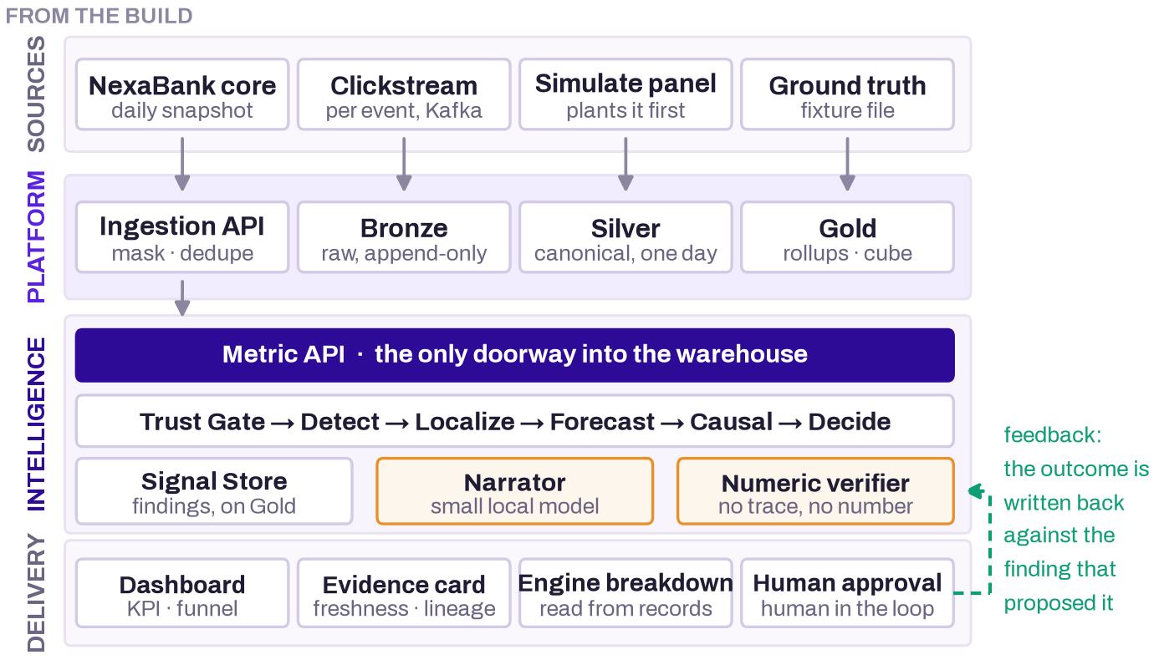
Two properties carry most of the governance weight. The intelligence stages never query raw events; they ask the Metric API for declared, additive fundamentals at an explicit grain, which stops a free-form answer engine turning into an ungoverned SQL layer. And the Signal Store sits between the tools and the narrator, so the narrator physically cannot see anything that has not already been computed, verified and recorded.
The three warehouse layers are conventional, deliberately so. Bronze holds raw events exactly as received and is never edited, which is what makes it the audit trail. Silver is cleaned: names canonicalised, duplicates removed by event identity, personal data masked, sessions rebuilt, one agreed day and timezone. Gold holds the serving rollups, the segment cube and the Signal Store. The dashboard and the tools read Silver and Gold. Neither ever reads Bronze.
2.3 The Trust Gate has five answers, not two
This is the component the rest of the proposal rests on. Most analytics systems have two states: answer, or error. This one has five. Each produces a different artefact for the business and a different one for engineering, so a refusal has somewhere to go instead of being a dead end.
Input condition | Verdict | Emitted to the business | Emitted to engineering
A hard invariant fails | QUARANTINE | Nothing. The metric is withheld and the movement is never narrated. | Incident note naming the failing check
The movement is real and material | PASS | The full finding: trust, driver, trajectory, cause, action, owner. | Nothing
History is too short to trust | WIDE BAND | Movement and localisation only. The forecast comes back as an explicit wide band. | Coverage note
A defect and a real event both fit | ABSTAIN | Ranked hypotheses, what is missing, and the single cheapest check that settles it. | Data request
The reader is not entitled | WITHHOLD | The figure is structurally absent from the bundle, and so is anything it could be back-computed from. | Access-decision log

Why five and not two
A binary gate pushes every ambiguous case into one of two wrong answers: publish a number that might be an artefact, or bury a movement that might be real. The middle three verdicts exist because those are the cases that actually turn up. WIDE BAND keeps a genuine movement visible while refusing to pretend the forecast is tight. ABSTAIN turns a stalemate into a work item by naming the cheapest check. WITHHOLD removes a figure structurally rather than redacting it afterwards, which is the difference between an entitlement control and a display rule.

2.4 Four properties the commercial claims rest on
Property | What it means in the build | The claim it makes defensible
Determinism | Every figure is computed on CPU with no training data. The same frozen rows produce byte-identical numeric output. | A figure can be reproduced in an audit six months later without an engineer
Optional narrative | Turning the narrator off changes no number. Findings fall back to a bounded template and the verifier still runs. | The bank is never operationally dependent on a model provider
Declared contracts | One YAML per metric: formula, grain, materiality threshold, freshness SLA, entitlement scope, permitted dimensions, owners, levers. | Onboarding a second institution is configuration, not a rebuild
In-tenant residency | The Signal Store and the narrator both run inside the tenant. Raw events never enter model context. | Payment data never leaves the jurisdiction, and the prompt-injection surface stays closed

Residency is not a preference here. Since April 2018 the Reserve Bank of India has required payment system operators to store the full end-to-end details of payment transactions on systems located only in India, with compliance evidenced by a board-approved audit from a CERT-In empanelled auditor (RBI circular RBI/2017-18/153). A design that posts raw banking data to an external model endpoint does not clear that review. Ours never sends one.

Section 3
Five metrics, two cadences,
one causal spine
We build one connected chain rather than twenty independent metrics, because a chain answers questions a collection cannot. Why did revenue drop is answered by walking it.
Five is a deliberate number. It is enough for a movement in one metric to explain a movement in another, and few enough that each one can carry a real contract, real quality rules and a named owner instead of a placeholder.
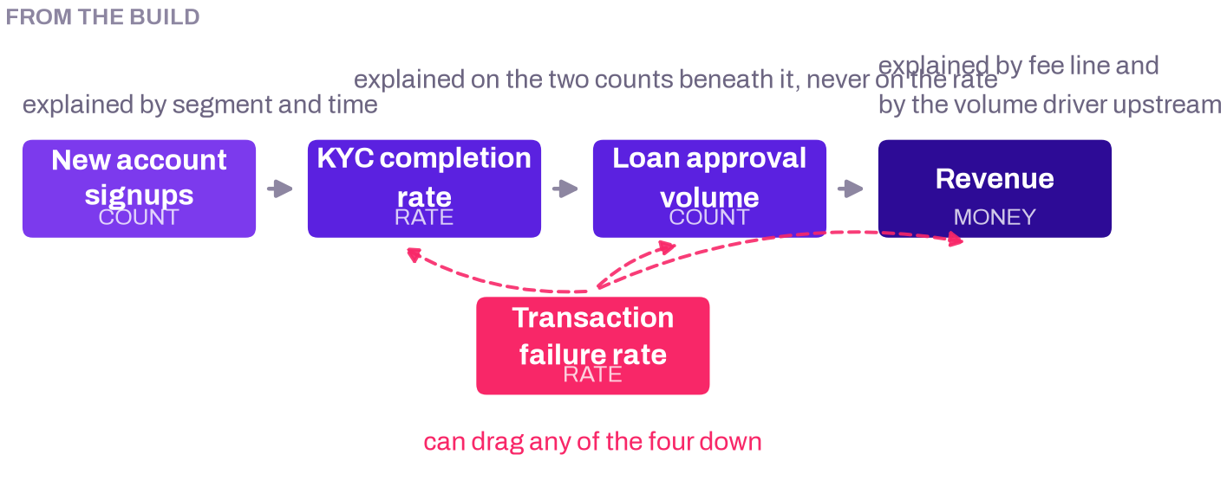
Fewer signups or weaker KYC completion lead to fewer approvals, which lead to lower revenue. A failure spike can drag any of them down. Because the contracts declare these edges, several metrics moving at once become one story with a driver chain instead of four alerts a human has to recognise as the same incident.
3.1 The method follows the shape of the metric
This is a bank, not a shop, so we do not use a retail price, volume and mix decomposition. The reason is arithmetic rather than taste. Adtributor’s authors made the same distinction in 2014: a derived measure such as a ratio cannot be attributed the way an additive measure can, because a single element can show zero surprise and still account for more than 100% of the change (Bhagwan et al., USENIX NSDI 2014).
Shape | KPIs | How a movement gets explained
Rate through a funnel | KYC completion, transaction failure | Always on the two underlying counts, never on the ratio. Which stage leaked, and which segment drove the leak.
Count | Signups, loan approval volume | Segment and time, over the additive cube. Contributions sum, so the residual means something.
Money | Revenue | Which fee line moved, then which upstream volume driver in the chain moved it.

3.2 Two sources, two cadences, one rule about which one counts
Source | Grain and cadence | Role | SLA
Daily banking snapshot | Application, account and transaction grain, extracted once a day from NexaBank’s Postgres | Produces every KPI value. All five numbers come from here. | 120 min
Real-time clickstream | Per event, streamed through Kafka | Behavioural context only. Funnel-stage detail and journey reconstruction. Never a figure a reader sees as a KPI. | 15 min
The two cadences are the point, not an inconvenience. Each source carries its own SLA, and a KPI combining a real-time number with a daily one is computed against the oldest common data time. Too large a gap is itself a finding.
The discipline behind that split matters more than it reads. The clickstream sees a customer begin identity verification in the interface, but it covers only the sampled population and its dimensions are synthesised per session. Use it as a denominator and you get a confident, wrong completion rate. The contract says so in writing, so an analyst challenging the figure can see which source produced it without asking anyone.
3.3 The contract is the semantic layer and the portability layer at once
One YAML file per metric declares everything the engine is allowed to assume. The narrator uses these definitions and nothing else, which makes metric meaning configuration rather than code.
id: kyc_completion_rate
formula: kyc_completed / kyc_started # the RATE is not additive.
additivity: non-additive # its two counts are.
aliases: [kyc, identity verification, onboarding completion]
grain: {time: daily, entity: application}

sources:
- id: nexabank_core # the value comes from core banking
cadence: hourly_batch
freshness_sla_minutes: 120
- id: nexabank_clickstream
role: corroboration # counts UI starts, not submissions

detect: {fdr: benjamini_hochberg, persistence_windows: 3}
localize: {dimensions: [channel, region, device, kyc_step]}
levers: [fix_kyc_step, review_document_rules, escalate_vendor]
visibility: {cfo: full, ops_manager: full, analyst: method}
An abridged contract, from the build. It declares the definition, the grain, the additive fundamentals, which dimensions may be localised, the reliability checks, the access rules and the closed list of actions Decide may recommend. Contracts name physical columns and are validated against the live schema rather than trusted, because a contract naming a key that does not exist reads empty rather than failing loudly.
The commercial consequence is direct. Onboarding a new institution means mapping its event vocabulary and writing its contracts. It does not mean rewriting the reasoning stages. One is a product. The other is a consulting engagement.

Section 4
Three readers, one set of verified claims
A persona changes emphasis, depth and entitlement. It never changes the underlying number.
Reader | Today | With FinInsights | Cadence
CFO | Waits for a weekly pack. Follow-ups take days. | Position and outlook on demand, with revenue at risk attached to the driver that explains it | Weekly and ad hoc
Operations Manager | Knows a metric fell. Guesses the segment. | A named segment, a named lever, a named owner, and impact as a range, with revenue structurally absent | Daily
Analyst | Spends the day verifying and segmenting. | Reviews and challenges a completed investigation, including the method and the residual | Daily
Risk and audit read the same evidence bundle without a persona of their own in the prototype. A dedicated reader is Phase 2 configuration, not engineering.
4.1 Entitlement is enforced, not displayed
Personas resolve server-side, so a request can never widen access. The Metric API applies the row-level entitlement clause declared in the contract, and it does so before any claim is assembled. A restricted figure is never phrased and then redacted. It is never built.
The check most implementations miss is the second-order one. If a restricted numerator could be back-computed from a published ratio, that ratio is suppressed too. Section 5.4 shows it running.
4.2 The decision workflow, end to end
• Signal. A scheduled sweep or a user question pins a KPI, a time window and an ingest watermark.
• Evidence. The Metric API reads declared fundamentals. The Trust Gate checks readiness, quality, reconciliation and freshness, then issues one of five verdicts.
• Explanation. Detect, Localize, Forecast and Causal build the finding to the depth the contract permits and no further. The causal ceiling is declared, not discovered.
• Action. Decide proposes a contract-approved lever and names the accountable owner, with expected impact as a range.
• Review. The reader sees the verified narrative and the evidence trail. A human approves any action, and the outcome is written back against the finding that proposed it.

Section 5
The four scenarios, on one seeded dataset
The brief asks for four specific behaviours. Each one below runs on a single seeded NexaBank dataset, and every anomaly exists in the source data before the engine sees it.
Two rules that keep this section honest
First, an anomaly has to exist in the source data before the engine sees it. When a scenario says loan demand spikes, NexaBank generates the extra loan events, and the simulator writes its own ground truth to a fixture file. The gate script then scores the Signal Store against that fixture rather than against our expectations.
Second, the four charts below are worked examples, not production output. They are tagged illustrative on the chart itself. This prototype has run on seeded data, not at a client and not at production volume. Presenting a modelled series as a measured one is the exact failure this product exists to prevent, so we do not do it in our own proposal either.

Every scenario starts the same way, with a decision about whether there is anything to discuss at all. Detect scores the day against the stored forecast band using median and median-absolute-deviation residuals, so a fresh anomaly cannot quietly contaminate its own baseline. It fires only when a move is unlikely, material and persistent across several windows.
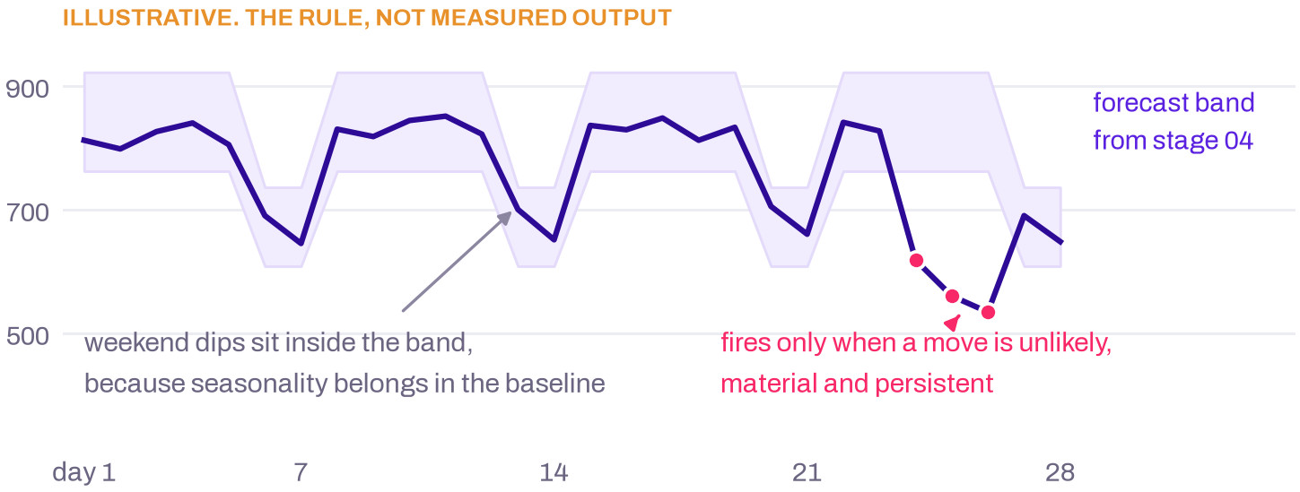
Detection on loan approval volume. The persistence window and the false-discovery alpha are both declared in the KPI contract, so what counts as material is a business decision rather than an engineering default.
Across many series, volume alone manufactures alarms, so p-values are corrected with Benjamini-Hochberg false discovery control. That is not a tuned threshold. It is a published method that gives a guaranteed lower bound on precision without any labelled data (Rebjock et al., NeurIPS 2021).
5.1 A multi-factor movement, with the residual published
Revenue drops. The engine walks the chain instead of modelling revenue directly, and reports one story with ranked contributions rather than four simultaneous alerts.
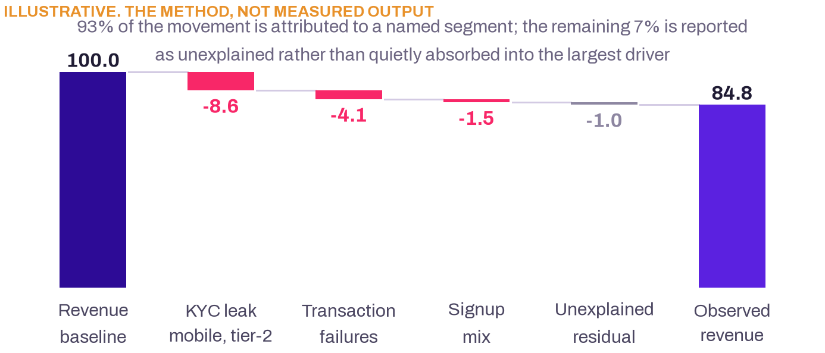
Contribution decomposition, drawn as a waterfall. Contributions are computed on additive counts only, and the unexplained residual is published rather than absorbed into the largest driver.
Publishing the residual is not modesty. PSqueeze is the first localisation method to detect root causes lying outside the recorded cube, reporting 0.90 F1 on that task, and the paper is explicit that earlier approaches returned a confident but wrong attribution in the same situation (Li et al., Journal of Systems and Software, 2023). A method that can be wrong quietly is worse than one that says so.
5.2 Low confidence, and a refusal that names its own next step
A spike arrives that the Trust Gate suspects is a duplicated batch, while the calendar shows a marketing campaign in the same window. The evidence genuinely conflicts, so the engine abstains.
What the reader actually receives
A 41% rise in signups was detected between 12 and 18 August and is not being reported as a business movement. Two explanations fit the evidence: a duplicated ingest batch, and the tier-2 campaign that launched on 12 August. The cheapest check that separates them is a distinct count of source event identities for 12 to 14 August against the batch manifest. Until that check returns, no figure from this window is published.

Abstention is not silence. It names the ranked hypotheses, what is missing, and the one check that would settle it, which turns a stalemate into a work item with an owner. It is also worth designing rather than hoping for: on Vectara’s leaderboard, model answer rates range from 100% down to 67%, so willingness to decline varies enormously between models and cannot be left to the model’s discretion (Vectara HHEM leaderboard).
5.3 A new product with nine days of history
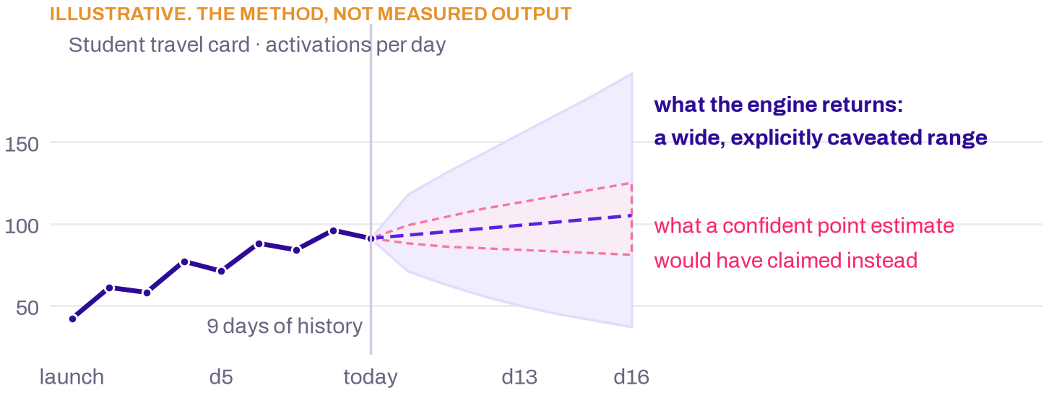
A sparse series returns a wide, explicitly caveated range and the number of days available. Detect does not fire. Localize abstains per dimension below a minimum cell count. Thin history is a first-class output here, not a degraded one.
The method changes with data volume. The honesty does not. The forecast registry will only use a method that beats the contract’s own baseline on rolling-origin MASE for that series, so a model never gets chosen simply because it is available.
5.4 The same insight, two readers, one claim set
 | CFO | Operations Manager
Movement | KYC completion fell 6.2 points week on week | KYC completion fell 6.2 points week on week
Driver | Mobile, tier-2 cities, document upload step. 71% of the drop. | Mobile, tier-2 cities, document upload step. 71% of the drop.
Revenue at risk | $84K over the quarter | Absent from the bundle. Not redacted. Never assembled.
Approval-rate ratio | Shown | Suppressed, because revenue at risk can be back-computed from it
Action | Noted, with the owning function named | Escalate to the identity vendor. Owner: onboarding operations. Expected recovery 20% to 80% of the gap.
Illustrative, using the entitlement rules the contracts declare.
5.5 Coverage against the brief’s minimum expectations
The brief asks for | Where this proposal satisfies it
Three to five connected KPIs across two or three sources with different cadences | Five-KPI chain over two sources at daily and per-event cadence, section 3
A lightweight KPI or semantic contract | One YAML per metric: definition, calculation, drivers, thresholds, lineage, access. Section 3.3
At least two personas with different narratives or actions | Three, resolved server-side, over one claim set. Sections 4 and 5.4
One multi-factor movement with known drivers | Revenue drop decomposed across KYC leak, failures and mix. Section 5.1
One low-confidence scenario with clarification or abstention | The ABSTAIN verdict, with the cheapest confirming check named. Section 5.2
One sparse-history or newly launched KPI | Nine-day product launch returning a wide caveated band. Section 5.3
One role-based security or entitlement scenario | Revenue withheld from operations, and the ratio suppressed too. Section 5.4
Evidence: freshness, method, contribution, confidence, lineage | The evidence card carried by every insight. Section 6.1
A clear breakdown of LLM versus non-LLM processing | Engine tags stored per figure, read back rather than asserted. Sections 2 and 6.2
Runtime telemetry: latency, model calls, tokens, estimated cost | Observe, one row per stage per run. Section 6.3

Section 6
What travels with every insight
An insight nobody can interrogate is a rumour with formatting. Three artefacts travel with every finding, and all three are read from stored records.
6.1 The evidence card
Field | What it holds | Why a sceptic needs it
Freshness | Data time per source against that source’s SLA | Tells a real decline apart from a late batch
Method | Which tool ran, with its parameters | Lets the method be argued with rather than trusted
Contribution | Each driver’s share, and the unexplained residual | Shows what the explanation does not cover
Confidence | The interval, and the basis for it | Separates a tight estimate from a wide one
Lineage | Metric id, contract version, query hash, window, source rows | Reproduces the figure without an engineer

6.2 The engine breakdown is a query, not the model’s opinion
Every produced number is tagged at the moment it is computed with the engine that made it: SQL, statistics, rules, ML or LLM. The breakdown shown on an insight is a query over those tags. It is a fact about what ran, never a claim the model makes about itself.
The alternative is unfalsifiable, and worse than it sounds. Ask a model which parts of its answer were computed rather than generated and you get a fluent, plausible answer with no relationship to what happened. Grounded hallucination does not reach zero for any model on Vectara’s leaderboard, even when the source text is handed to it, which is why an independent numeric verifier sits between the narrator and the reader (Vectara, May 2026).
6.3 Run cost is measured, not asserted
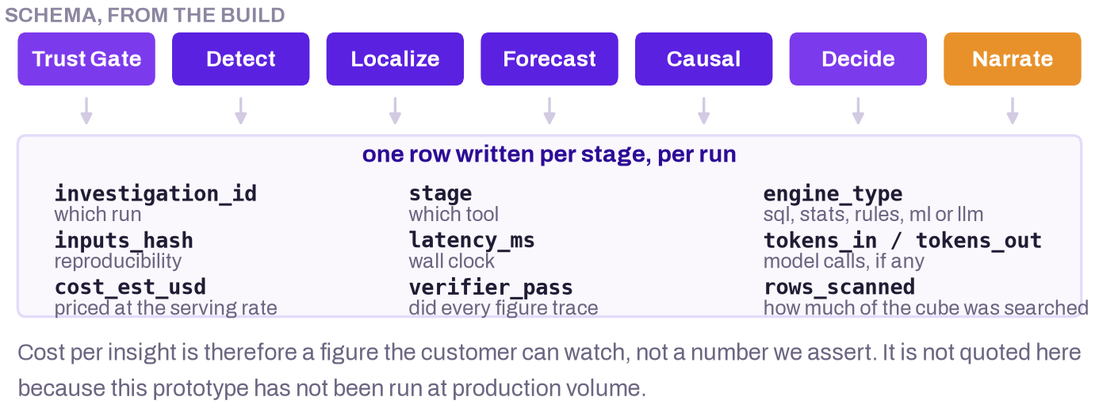
Observe writes one row per stage per run. Because engine, latency, tokens, estimated cost and verifier status are columns rather than estimates, the marginal cost of an additional governed metric is something the customer watches rather than something we claim.
The cost shape is the argument for a small local model. Narration is output-heavy, and output tokens are the expensive kind on hosted APIs, so a narration-heavy design is the costly one to outsource. Quality does not obviously argue the other way either: on the same faithfulness leaderboard, Microsoft’s Phi-4 sits at 3.7% and Llama-3.3-70B at 4.1%, against 3.1% for GPT-5.4-nano (Vectara, May 2026). For a stage whose only job is to phrase numbers it has been handed, a small model is competitive, and it sits behind your firewall.
What we are not claiming
We are not quoting a cost per insight. This prototype has not run at production volume, so any figure we published would be an estimate dressed as a measurement. Self-hosting also only beats a managed API above a workload floor, and an idle GPU inflates unit cost badly. Our case for on-premise serving rests on data residency first and cost second. If a bank’s volume sits below the floor, the deployment is still correct. It is just not cheaper, and we would say so.

Section 7
Learning without retraining anything
One click on each insight: was the root cause correct, was this a known event such as a holiday, was the action taken. The response writes a structured row that does exactly three things.
• Adds a suppression or known-event rule that Detect reads on its next run.
• Adjusts a method-reliability weight used when ranking candidate causes.
• Corrects a definition in a KPI contract, with the change versioned.
No model is retrained, and no lever list is ever widened by learning. That boundary is deliberate. A feedback loop that can invent a new recommended action is a feedback loop that has escaped its governance.
The design has published support. GLAD shows analyst labels tuning the weights of an ensemble of simple, explainable detectors rather than replacing them, on a small and explicitly budgeted number of labels. Its stated premise is that practising analysts want to keep detectors they can explain (Islam, Das, Doppa and Natarajan, 2018).

Section 8
A floor we will defend line by line
The case is built as two numbers rather than one, because quoting only the larger of them would be the weaker position.
The floor is what we will argue for. The headline range adds two effects that are real but that we cannot bound tightly: the value of a decision taken in time, and the retention of analysts who stop spending their week on reconstruction. That range is quoted second and labelled modelled wherever it appears.
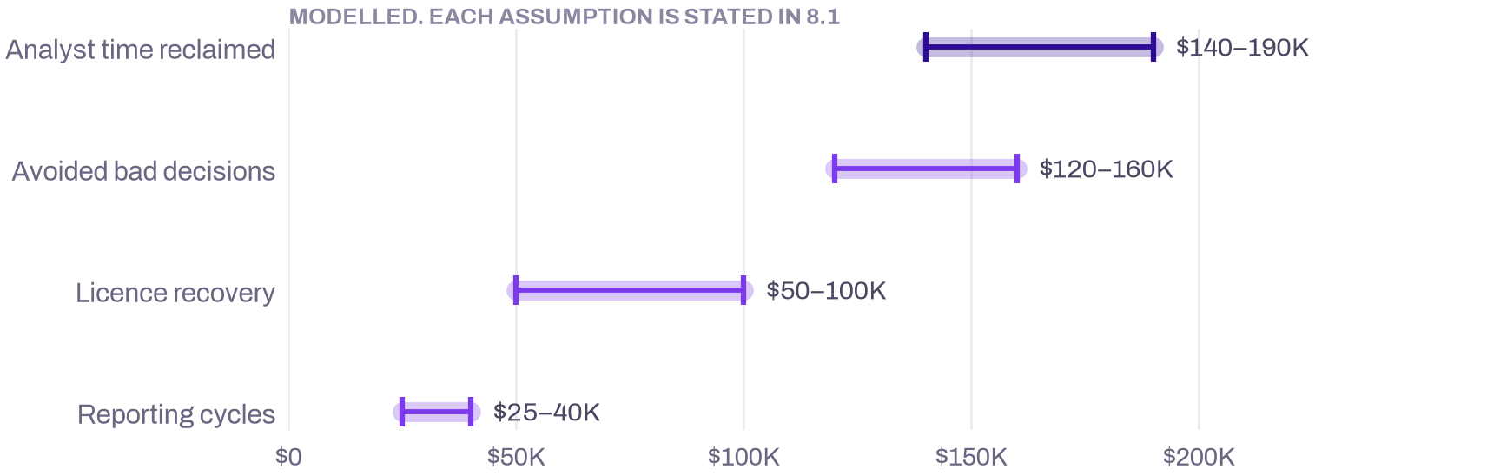
The four mechanisms that make up the floor. Analyst time is the largest single line and the only one whose unit cost is externally anchored rather than assumed.
8.1 Each line states its own assumption
Mechanism | Derivation | Low | High | Basis
Analyst time | 12 investigations a week, 5 hours reclaimed, 50 weeks, $55/hour | $140K | $190K | Unit cost sourced
Avoided bad decisions | 3 to 4 prevented incidents a year at about $40K each | $120K | $160K | Modelled
Reporting cycles | 2.5 people, 3 hours a week, 80% reduction, 50 weeks | $25K | $40K | Modelled
Licence recovery | Idle entitlement de-provisioning and behaviour-justified upsell | $50K | $100K | Zylo 2025
Defensible floor | Sum of the four mechanisms above | $335K | $490K | Bottom-up
Headline range | Adds in-time decision value and reduced analyst churn | $550K | $950K | Modelled
Zylo’s 2025 SaaS Management Index puts idle licences at 52.7% of those purchased. That anchors the licence-recovery line; the share we assume you can actually reclaim is ours.
8.2 Payback lands between months three and five
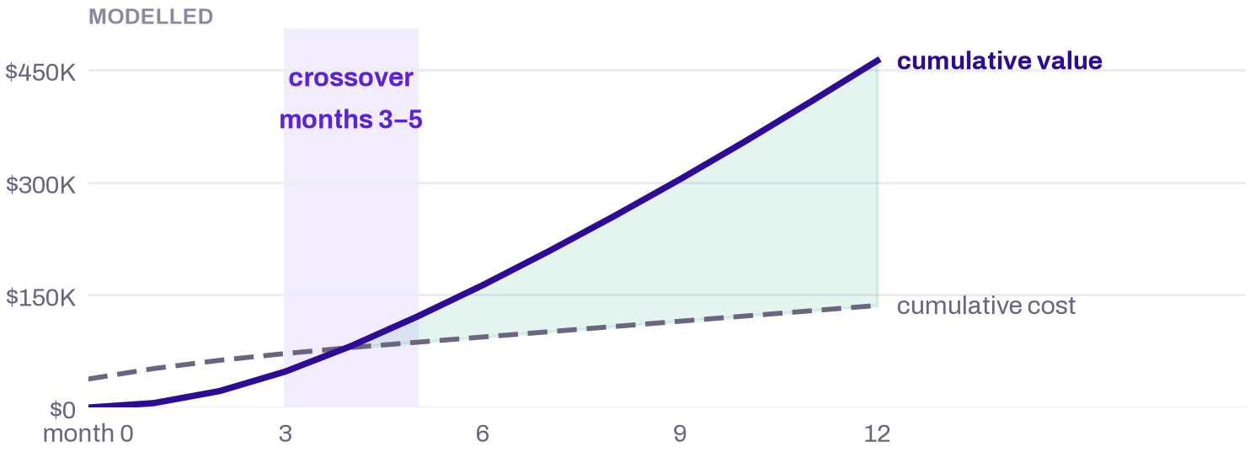
Cumulative modelled value against cumulative cost. Value ramps from month two, the point at which the first contracts clear the Trust Gate, rather than from day one, because a contract that has not passed a gate produces nothing worth counting.
8.3 What moves the number, and by how much
Showing this is a commercial choice. A buyer who can see which assumption is load-bearing will argue about that assumption instead of dismissing the whole model.
Driver | Downside | Base | Upside | Effect on the total
Governed metric count | 5 | 10 | 25 | Roughly linear on three of four lines
Upstream data quality | Clean | Mixed | Fragmented | Plus or minus $60K on the bad-decision line
Reclaimable share of a day | 60% | 85 to 90% | 92% | Plus or minus $50K on the analyst line
Roles duplicating reporting | 1 shared | 2 to 3 | 4 or more | Plus or minus $20K, independent of size
Loaded analyst cost | India, $30K | US, $110K | US, $150K | Rescales the largest line

The last row changes the shape of the argument rather than its size. At an India-loaded analyst cost the analyst-time mechanism shrinks by roughly two thirds, and the case has to be carried by decision quality and licence recovery instead. That is a different sale, and it is worth knowing before the meeting.
8.4 Baseline and method
The baseline institution throughout is a mid-size retail bank: 150 to 400 staff across operations, risk and analytics, a data function of 6 to 12 people, and a metric footprint comparable to the chain in section 3. Cost inputs are anchored to a US senior analyst at $110K fully loaded, about $55 an hour. Incident frequency, per-decision cost, the payback profile and the headline range are modelled from those inputs. None of them is measured at a client.
How to use this section
Every line carries one of two labels. Unit cost sourced means the unit comes from an external reference and only the volume is ours. Modelled means both are ours, stated above so you can replace them. The right way to use this business case is to run a pilot that turns the modelled lines into measured ones, which is exactly what the Phase 1 exit criterion is designed to produce.

Section 9
Three phases, each gated on evidence
rather than on a date
Phase 1 is built and running today. Every phase exits on a test a sceptic could run themselves, and recommendations stay human-approved in all three without exception.
The shape of the plan matters as much as its content. Each phase hands the next one a proof rather than a promise, and each gate belongs to the function that would otherwise be the one to stop the programme later.
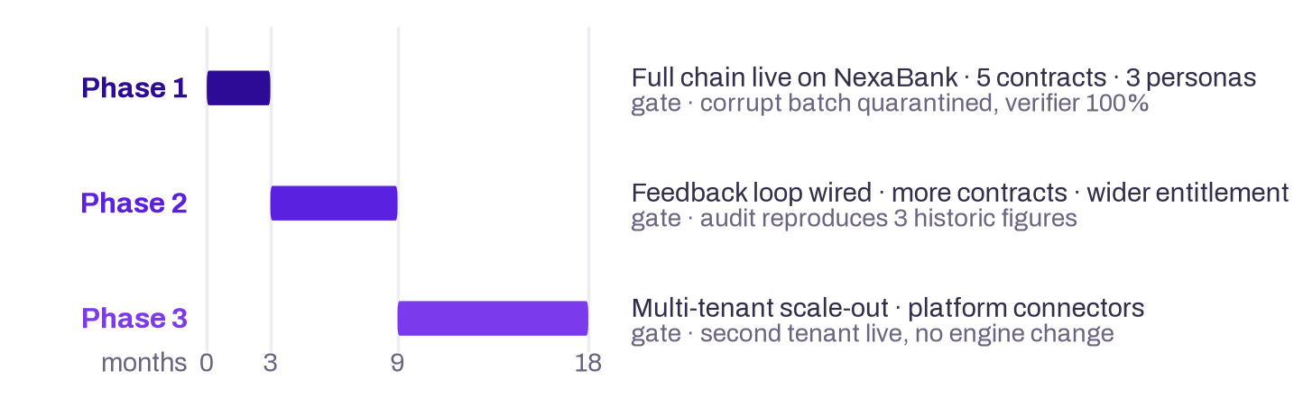
Giving each gate to the function most likely to block the programme is what stops a gate becoming a formality.
Phase | Scope delivered | Exit criterion | Gate owner
1, built today  months 0 to 3 | The full chain live end to end on NexaBank telemetry. Five KPI contracts, the ClickHouse Signal Store, Observe on every stage, three personas. | The Trust Gate quarantines a seeded corrupt batch. The verifier passes on every published figure. Analyst review completes inside 60 minutes. | Head of Analytics
2, near term  months 3 to 9 | The feedback loop wired to the outcomes table. More contracts across more sources. Readers and entitlements widened beyond the first three. | Overrides recalibrate the next run. Risk or audit reproduces three historic figures from the evidence bundle alone. | CRO or Model Risk
3, scale out  months 9 to 18 | Multi-tenant scale-out. Connectors for Databricks, Snowflake, Fabric, Tableau, Qlik and Looker, native, custom or hybrid. ClickHouse stays the analytical core. | A second institution live with no engine change. 25 or more contracts governed. Documented run-rate value of $500K or more. | CFO or CDO

9.1 What stays out of scope, in every phase
These are boundaries rather than a backlog. Each one exists because crossing it would break a claim made elsewhere in this document.
Excluded | Why it stays out
Automated action without human approval | Every action is approved by a named person and the outcome logged. Remove that step and the regulatory posture in section 10.2 stops holding.
Self-learning recommendation ranking | Overrides are captured from day one, but recalibration is designed rather than deployed. Learning must never widen a contract’s lever list.
Model-driven credit or risk decisions | Out of scope entirely. Decide picks from a fixed lever ontology and never invents an action, which is also what keeps the system clear of the EU AI Act’s high-risk classification.

9.2 Who owns what
• Product and business. KPI definitions, materiality thresholds, decision owners, permitted levers, acceptance scenarios.
• Data and platform. Source extracts, Metric API mappings, freshness, schema stability, tenant isolation.
• Analytics and intelligence. Stage methods, Signal Store integrity, deterministic output, the evaluation gates at each phase exit.
• Security and governance. Identity verification, role mapping, entitlement review, audit policy.
• Operations. Review findings, approve actions, capture outcomes, feed usefulness signals back.

Section 10
The three risks that would kill this
are not technical
Scored 1 to 5, inherent and residual, each with a named control and a named owner.
Programmes of this shape rarely fail on the mathematics. They fail because a pilot produced nothing anyone could measure, because an audit function would not sign off, or because the analysts it was built for quietly declined to use it. Those are R1, R4 and R5, and each has a control that is a product decision rather than a promise.
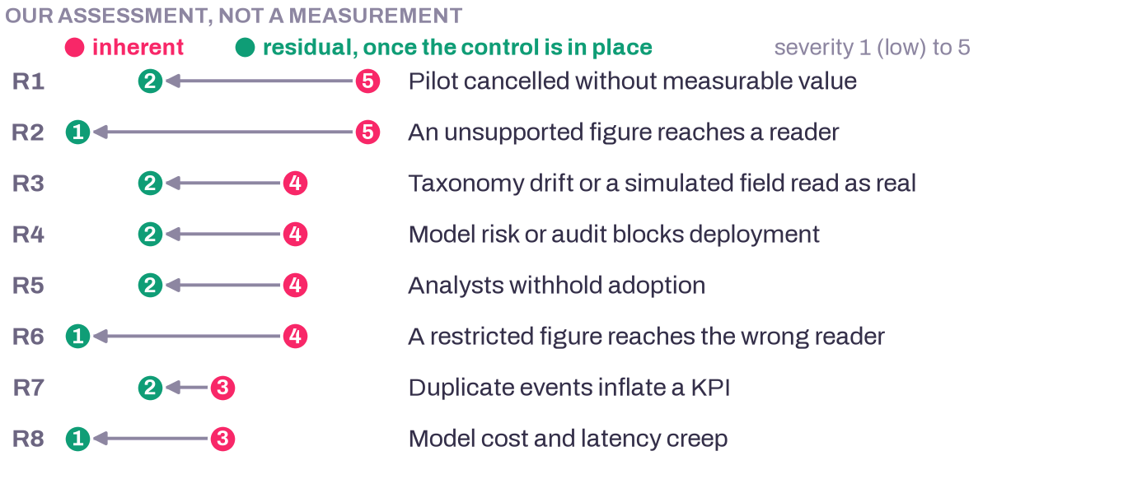
Every risk drops at least two points once its control is in place. R5 stops at 2 rather than 1 because adoption is behavioural and cannot be closed by design alone. It is re-scored at the Phase 2 gate on observed usage.
 | Risk | Inh. | Control | Res. | Owner
R1 | Pilot delivers no measurable change and is cancelled | 5 | Scope fixed to contracts already live. Value measured per contract against a pre-agreed baseline. | 2 | Champion
R2 | The narrator states a figure the evidence does not support | 5 | It sees evidence bundles, never raw events. The verifier traces every figure, then regenerate, redact, template. | 1 | Engineering
R3 | Taxonomy drift, or a simulated field read as real evidence | 4 | Read-time canonicalisation and pre-deploy checks. Simulated fields labelled in contract and narrative. | 2 | Data Eng
R4 | Model risk or audit blocks deployment | 4 | Determinism plus a per-figure evidence bundle meets model-risk documentation expectations. No credit decisioning. | 2 | CRO
R5 | Analysts treat it as a threat and withhold adoption | 4 | Positioned as review and challenge. The analyst persona exposes the full bundle. Overrides are logged and feed Phase 2. | 2 | Head of Analytics
R6 | A restricted figure reaches the wrong reader | 4 | Tenant selected by application, never a query parameter. Personas resolved server-side. Row-level clause in the Metric API. | 1 | Security
R7 | Duplicate events from at-least-once delivery inflate a KPI | 3 | Replay-safe aggregation, exact-distinct on every count, Bronze append-only with both timestamps preserved. | 2 | Data Eng
R8 | Model cost and latency creep as volume grows | 3 | Narrator-only small-model design. Observe records tokens, latency and cost per insight. The narrator is optional. | 1 | Engineering

10.1 The evidence behind the three that matter
Risk | What the evidence says | The control
R1 Pilot cancelled | Gartner predicts over 40% of agentic AI projects will be cancelled by the end of 2027 on escalating cost, unclear value and weak risk controls (Gartner, June 2025). S&P Global’s survey of 1,006 IT and business leaders found abandonment of most AI initiatives rose from 17% to 42% year on year, with 46% of projects scrapped between proof of concept and broad adoption (S&P Global, 2025). | Value is measured per governed metric against a pre-agreed baseline, and every phase gate is a test a sceptic can run.
R2 A fluent answer the data does not support | Leading text-to-SQL systems still miss about one BIRD question in five, and grounded hallucination reaches zero for no model on the Vectara leaderboard. Error analysis on financial tables attributes 20% to 28% of failures to arithmetic itself rather than retrieval (arXiv:2402.11194). | The narrator receives typed evidence bundles only. The verifier traces every figure back to the store, then bounded regeneration, redaction, template.
R5 Adoption stalls inside the analyst function | Klarna publicly reversed part of its customer service automation during 2025 and rehired human agents. The pattern is over-reach, then retrenchment, and it is worth planning around rather than assuming away. | Nothing acts on its own. Human approval sits in the delivery path, every action has a named owner, and the outcome is logged.
The Klarna reversal is widely reported but we have not sourced it to a company statement, so it is offered as an industry pattern rather than as a measured finding.
10.2 Regulatory posture
Two regimes matter for a product of this shape. Determinism plus a per-figure evidence bundle speaks directly to model-risk documentation expectations: the model inventory entry can point at a reproducible numeric path instead of a black box with a validation report stapled to it.
The second is scope. Because the product makes no credit or risk decision, and Decide proposes from a fixed lever ontology with a human approving, it sits outside the EU AI Act’s Annex III high-risk classification, where creditworthiness assessment appears (Regulation (EU) 2024/1689). That is a deliberate scoping choice, not a lucky accident.
The compliance gatekeeper’s real test is narrower than either regime suggests. Can risk or audit reproduce a figure published six months ago, from stored evidence alone, without asking an engineer? That is written into the Phase 2 exit criterion as a concrete test on three historic figures.

Section 11
What to test during a pilot
Each dimension below is something you can run on your own data, not a claim you have to accept.
Dimension | The test
Truth | Every narrated figure traces to a Signal Store row or a contract field. Verifier coverage is 100%.
Reliability | Defect scenarios are quarantined. Ambiguous ones abstain with a named confirming check.
Detection | The planted movement is found while normal windows stay quiet. Both halves matter.
Localisation | The planted segment ranks first, using additive measured dimensions only.
Forecasting | Every eligible KPI has a stored interval, method and caveat, or an honest sparse-history response.
Consistency | The same frozen rows produce byte-identical numeric output.
Governance | No restricted KPI, and no back-computable restricted figure, reaches an unauthorised reader.
Adoption | Users answer supported questions without a data-team ticket, and can identify source, window and owner.
Action | Recommendations are contract-approved, owner-assigned and human-approved. Outcomes are recorded.
Economics | Observe reports tokens, latency and cost per insight. Cost per governed metric is measured, not estimated.

Measure the baseline first
Capture the current investigation cycle before anything is switched on: elapsed time, analyst hours, handoffs and rework per movement. Without that measurement the value model in section 8 stays modelled forever, and a modelled number is the one a sceptic discounts.

Section 12
Land on one expensive decision loop
The entry point is not a dashboard replacement. It is a single loop in lending and onboarding, where a delayed or untrusted answer carries a visible operational cost.
Motion | The offer | The customer’s proof
Land | One tenant, three connected KPIs, one persona set | Time to answer, trust verdicts and action ownership, measured against the current process
Prove | A controlled pilot across normal, defect, sparse and permission scenarios | No unsupported figures, no entitlement leaks, correct treatment of ambiguous data
Expand | Finance, acquisition and product metrics through contract workshops | More governed coverage without proportional engineering effort
Scale | Multi-tenant platform and the source connector programme | A second institution onboarded through contracts and mappings, not stage rewrites

12.1 Market sizing, with the filter stated as an assumption
The institution count is sourced. The contract value and the readiness filter are ours, and we say so rather than dressing them in someone else’s research. The FDIC’s Quarterly Banking Profile for the first quarter of 2026 reports 4,278 insured commercial banks and savings institutions, down 60 over the quarter (FDIC, May 2026).
Tier | Scope | Basis | Annual value
TAM | 4,278 FDIC-insured institutions | Sourced count, multiplied by a $150K assumed contract value | $641.7M
SAM | About 1,070 institutions | Our assumption: roughly a quarter have the data maturity to run this within a year | $160.5M
SOM year 1 | 3 accounts | Initial pilot conversions | $0.45M
SOM year 2 | 12 accounts | Regional bank expansion | $1.80M
SOM year 3 | 30 accounts | Three-year phased capture | $4.50M
An earlier draft attributed the readiness filter to published research. We could not verify that attribution, so the filter now stands as our assumption. It is the first number to challenge, and the pilot is what would replace it.
12.2 Why this is differentiated
• Against BI. It says whether a movement is credible and what to do next, not only what happened.
• Against alerting. It controls false discoveries and folds related movements into one story instead of several alerts.
• Against conversational analytics. It refuses unsupported answers, preserves the claim set, and applies access before narration rather than after.
• Against bespoke consulting. Contracts and the Metric API make onboarding repeatable across tenants and domains.

Section 13
Approve a governed pilot on the
lending and onboarding loop
FinInsights has a clear product boundary and a credible wedge: make the analytics you already own trustworthy, explainable and actionable for the people who carry the decision. The architecture is already shaped for a repeatable platform. The business case is strongest when the first pilot measures a baseline rather than asking the narrative layer to prove value on its own.
Start where KYC completion, loan approval volume and revenue form one connected story. Add finance and acquisition metrics once the trust and entitlement workflow is proven. Use the pilot to turn the modelled lines in section 8 into measured ones: investigation time, false-positive suppression, answer adoption, recommendation acceptance and realised operational impact.
Decision requested
Authorise a KPI-contract and source-readiness pilot for one tenant, with operations, finance, analytics and risk represented in acceptance. Phase expansion is gated by evidence quality, not by narrative fluency. The Phase 1 exit criterion is that the Trust Gate quarantines a seeded corrupt batch, the numeric verifier passes on every published figure, and analyst review completes inside sixty minutes.

The team
Member | Institution | Stream | Year
Omesh Mehta, team lead | IIT Patna | Chemical and Biochemical Engineering | 2027
Abhishek Kumawat | IIT Patna | Chemical and Biochemical Engineering | 2027
Vinod Singh Rathore | IIT Patna | Mechanical Engineering | 2027

Appendix A
Method register
Each deterministic tool implements published work. This is the register a model-risk reviewer will ask for.
Stage | Method and source | What the source establishes
Detect | Online false discovery rate control for anomaly detection in time series. Rebjock, Kurt, Januschowski and Callot, NeurIPS 2021 | Treating each observation as a hypothesis test and applying an online Benjamini-Hochberg family gives a guaranteed lower bound on precision without labelled data. A principled cap on false alarms, rather than a tuned threshold.
Localize | PSqueeze. Li et al., Tsinghua, Nankai, Bizseer and China Construction Bank, Journal of Systems and Software, 2023 | Outperforms prior localisation methods by at least 32.89% F1 across 5,400 injected faults, localises in about ten seconds, and proves its ripple-effect property for both additive and derived measures. First method to detect root causes lying outside the recorded cube, at 0.90 F1.
Localize | Adtributor. Bhagwan et al., Microsoft Research, USENIX NSDI 2014 | Over 95% accuracy on 128 real production anomaly alerts, and the origin of the rule we follow that derived measures such as rates cannot be attributed the way additive measures can.
Localize | HotSpot. Sun et al., Tsinghua University and Baidu, IEEE Access, 2018 | Establishes the combinatorial scale of the problem, since a cuboid of n elements has 2 to the power n minus 1 candidate subsets, and reports localisation time falling from over an hour of manual work to under twenty seconds in production.
Causal | Difference-in-differences with a placebo test on a pre-treatment window | Attribution is not effect. The control group’s own pre-to-post ratio supplies the counterfactual, and running the same estimator on a window where treatment had not happened yet tests parallel trends rather than assuming it.
Feedback | GLAD: GLocalized Anomaly Detection via Human-in-the-Loop Learning. Islam, Das, Doppa and Natarajan, 2018 | Analyst labels tune the weights of an ensemble of simple, explainable detectors rather than replacing them, on a small explicit label budget. This is the design our one-click feedback implements.
Narrate | Vectara HHEM faithfulness leaderboard, updated May 2026 | Establishes both that grounded hallucination never reaches zero, hence an independent numeric verifier, and that small models are competitive on faithfulness with frontier ones.

Appendix B
References
Every external claim in this document, with a link. Nothing in this list is our measurement, and the note column carries the caveat that travels with the figure.
Publisher | Title and date, linked | What it is, and its limits
dbt Labs | 2026 State of Analytics Engineering Report  April 2026 | 363 data practitioners and leaders, fielded 5 December 2025 to 1 February 2026, 73% practitioners.
Microsoft and Omdia | Unify now or pay later: new research on the operational cost of a fragmented SOC (State of the SOC 2026)  17 February 2026 | 46% of alerts prove to be false positives and 42% go uninvestigated. This is security operations, not analytics. We cite it as the closest well-measured analogue for what a low-precision alerting surface does to the people reading it.
S&P Global Market Intelligence | AI experiences rapid adoption, but with mixed outcomes. Voice of the Enterprise: AI and Machine Learning, Use Cases 2025  2025 | 1,006 midlevel and senior IT and line-of-business professionals across North America and Europe. Abandonment of most AI initiatives rose from 17% to 42% year on year, with 46% of projects scrapped between proof of concept and broad adoption.
Gartner | Gartner Predicts Over 40% of Agentic AI Projects Will Be Canceled by End of 2027  25 June 2025 | A prediction, not a measurement. Gartner’s stated basis is a January 2025 poll of 3,412 webinar attendees.
Vectara | Hallucination Leaderboard (HHEM)  updated May 2026 | Measures grounded summarisation: the model is given the source text. Scored by a separate evaluation model, over 7,700 articles at temperature 0.
BIRD-SQL | BIRD text-to-SQL benchmark leaderboard  dataset NeurIPS 2023, leaderboard maintained since | 12,751 question and SQL pairs over 95 databases totalling 33.4 GB.
Lei et al. | Spider 2.0: Can Language Models Resolve Real-World Enterprise Text-to-SQL Workflows?  ICLR 2025, arXiv:2411.07763 | We cite the description of enterprise conditions, not the headline accuracy number, which the leaderboard has since moved past.
Srivastava, Malik, Gupta, Ganu and Roth | Evaluating LLMs’ Mathematical Reasoning in Financial Document Question Answering  arXiv:2402.11194, February 2024 | Multihiertt, FinQA and TAT-QA. Error analysis attributes 20.5% to 27.6% of failures to arithmetic rather than retrieval.
Li et al., Tsinghua, Nankai, Bizseer and China Construction Bank | Generic and Robust Localization of Multi-Dimensional Root Causes (PSqueeze)  Journal of Systems and Software, 2023 | Evaluated on two real-world datasets with 5,400 injected faults.
Bhagwan et al., Microsoft Research | Adtributor: Revenue Debugging in Advertising Systems  USENIX NSDI 2014 | Evaluated on 128 real anomaly alerts from two weeks of production data.
Sun et al., Tsinghua University and Baidu | HotSpot: Anomaly Localization for Additive KPIs with Multi-Dimensional Attributes  IEEE Access, 2018 | Reports localisation time falling from over an hour of manual work to under 20 seconds in production at a large search engine.
Rebjock, Kurt, Januschowski and Callot | Online false discovery rate control for anomaly detection in time series  NeurIPS 2021, arXiv:2112.03196 | Gives a guaranteed lower bound on precision without labelled data.
Islam, Das, Doppa and Natarajan | GLAD: GLocalized Anomaly Detection via Human-in-the-Loop Learning  arXiv:1810.01403, October 2018 | Analyst labels tune the weights of an ensemble of simple detectors; no retraining.
Reserve Bank of India | Storage of Payment System Data (RBI/2017-18/153, DPSS.CO.OD No.2785)  6 April 2018 | Binding on scheduled commercial, cooperative, payment, small finance and local area banks under the Payment and Settlement Systems Act 2007.
European Union | Regulation (EU) 2024/1689 (Artificial Intelligence Act), Article 6 and Annex III  2024 | Creditworthiness assessment is an Annex III high-risk use. This product makes no credit decision.
Federal Deposit Insurance Corporation | Quarterly Banking Profile, First Quarter 2026  May 2026 | 4,278 insured commercial banks and savings institutions, down 60 in the quarter.
Zylo | 2025 SaaS Management Index  January 2025 | Vendor research based on Zylo’s own customer telemetry.
Titles are clickable. Where a figure reached us through reporting rather than the original report, the note says so and the claim is treated as directional.
Claims we could not verify, and what we did about them
An earlier draft of this proposal cited a 91% versus 23% split on banking AI adoption, and an enterprise text-to-SQL accuracy of roughly 21% against 91% on academic benchmarks. We could not stand either up against a primary source at the time of writing, so both have been removed rather than softened. The market-readiness filter in section 12.1 now stands as our own assumption. The Klarna reversal in section 10.1 is reported rather than sourced to the company, and is framed as a pattern.

Appendix C
Glossary
Term | What it means in this product
KPI contract | The declared meaning, source fundamentals, grain, quality rules, dimensions, ownership, levers and visibility for one metric. One YAML file per metric.
Trust Gate | The stage that decides whether a figure may be used at all, issuing one of five verdicts: PASS, QUARANTINE, WIDE BAND, ABSTAIN or WITHHOLD.
Signal Store | The durable evidence store on Gold holding investigations, trust findings, anomalies, forecasts, causes, recommendations and run telemetry.
Evidence bundle | The typed set of verified figures and provenance the narrator receives. It never contains raw events, and a withheld figure is structurally absent from it.
Engine tag | The label attached to a figure at the moment it is computed: sql, stats, rules, ml or llm. The LLM versus non-LLM breakdown is a query over these.
Persona | A role-shaped view over one verified claim set. It changes emphasis, depth and entitlement, never the underlying number.
Investigation | One tenant, one KPI and one pinned time window processed through the chain.
Lever ontology | The fixed, contract-declared list of actions Decide may propose. Nothing outside the list can be recommended.
Causal rung | How strong a claim the evidence supports: association, attribution, corroborated cause, or estimated effect. Declared, not inferred.
Observe | Cross-stage telemetry recording latency, tokens, cost and verifier status per stage, which is what makes run cost a measured quantity.
Modelled figure | A derived or simulated value that carries its qualifier every time it is stated, in every persona.

